Nappy, the ingenious

Use-Case Specification: View Info

Revision History

|  |  |  |  |
| --- | --- | --- | --- |
| **Date** | **Version** | **Description** | **Author** |
| 21/11/2015 | 1.0 | Initial Version | Mehmet Ali Incekara |
| 26/11/2015 | 1.1 | Finishing touches and create PDF | Mehmet Ali Incekara |
| 30/11/2015 | 1.2 | Add SikuliX | Mehmet Ali Incekara |
| 19/04/2016 | 1.3 | Update UC (grammer, style, …) | Mehmet Ali Incekara |
| 06/06/2016 | 1.4 | Fix FP | Mehmet Ali Incekara |
|  |  |  |  |
|  |  |  |  |

Table of Contents

1. Use-Case View Info 4

1.1 Brief Description 4

2. Flow of Events 5

2.1 Basic Flow 5

2.2 Alternative Flows 6

3. Special Requirements 6

4. Preconditions 6

5. Postconditions 6

6. Extension Points 7

6.1 Function Points 7

Use-Case Specification: View Info

# Use-Case View Info

## Brief Description

Dieser Use-Case ermöglicht es dem Benutzer Informationen über das Spiel (Entwickler und ontaktmöglichkeiten) nachzulesen.

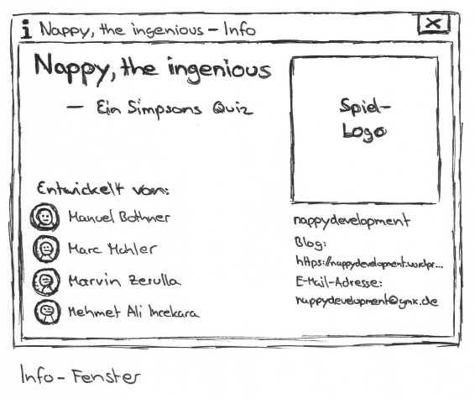

# Flow of Events

## Basic Flow

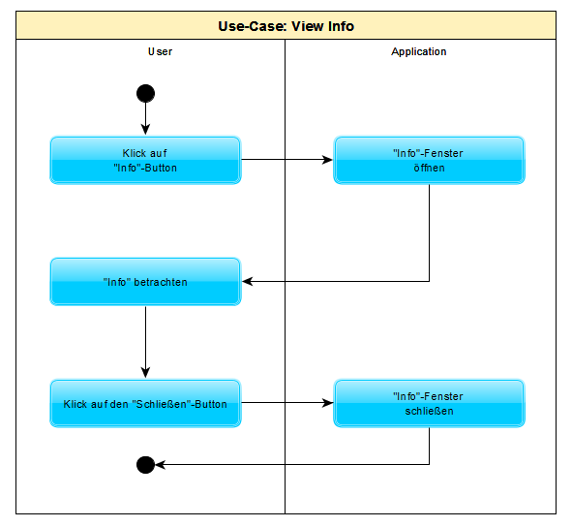

Aufgrund der Tatsache, dass Cucumber nicht für Desktop-Apps unterstützt wird, werden die Tests mit SikuluX 1.1.0 durchgeführt  
  
Scenario 1: Öffne Info

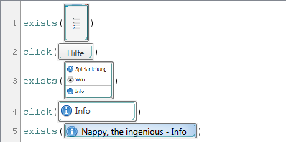

Scenario 2: Schließe Info

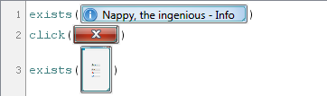

SikuliX-Directory: <https://github.com/nappydevelopment/docs/tree/master/sikulix>

## Alternative Flows

(n/a)

# Special Requirements

(n/a)

# Preconditions

(n/a)

# Postconditions

(n/a)

# Extension Points

## Function Points = 28,22

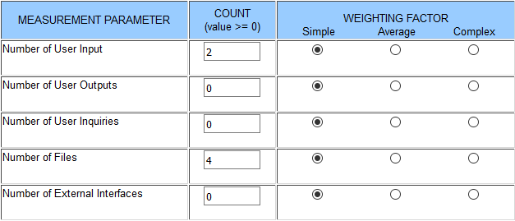

|  |  |  |  |
| --- | --- | --- | --- |
| **Transaction** | **DET’s** | **FTR’s | RET’s** | **Complexity** |
| EI Open Browser | 1 | 1 | Low |
| EI Open Mail Client | 1 | 1 | Low |
| ILF | 4 | 1 | Low |